Name ____________________________________ The Organization of the Human Body
Objective: Comprehend levels of organization of the human body by reading informational text, summarizing and making analogies.
PART 1: READING - Read below with your team, switching who is the reader and who is the summarizer each paragraph. The cloud should contain the MAIN IDEA of each paragraph.
Imagine you’re at lunch. Your nose smells pizza. Your legs move over to where hot lunch is being served. You have to balance the food and your milk in your hands, look around for a free seat, and then sit down. This may seem simple, many different parts of your body have to work together to make all of that happen. To make sure your body can work correctly, even when it does many things at once, your body must be carefully organized.

The smallest unit of our organization, our smallest part, is the cell. The cell is the building block of all living things, but you probably remembered that! Each human body is made up of over 100 trillion cells that have different structures and different functions. We have blood cells that carry oxygen to our muscles, and nerve cells that carry electrical impulses from our brains to the rest of our bodies. If the whole body is like a city, a cell is just one simple brick.

The next largest unit of organization in your body is a tissue. No, that’s not the same thing as what you blow your nose with. A tissue is a group of similar cells working together. If the whole body is a city, and a cell is just one brick, a tissue is one step bigger – a house.

There are four main types of tissues. Muscle tissue (which makes up muscles) can shorten to make your body move. Nervous tissue carries electrical signals between the brain and the body to control the body. Connective tissue, such as bone, blood and fat, connects the various parts of the body. And epithelial tissue, such as skin, covers the surfaces of your body.

The next largest unit of organization in your body is an organ. You’ve probably heard of organs before. Your heart, stomach, brain and lungs are all organs. Organs form when different types of tissue come together to perform a specific job for the body. If a cell is a brick, and a tissue is a house, an organ is like a city block.

An organ’s job is more complicated than a tissue’s job, which is why it takes more than one kind of tissue. For example, the heart is the organ responsible for pumping oxygen-rich blood to the rest of your body. To do this, it needs all four kinds of tissue. Muscle tissue helps the heart pump blood through your body, and the nervous tissue receives signals from the brain about when to pump.

The next largest level of organization smaller than your whole body is an organ system. Organ systems are groups of organs that work together to perform BIG jobs for your body. If an organ is like a city block, an organ system is like an entire neighborhood, like Back Bay.

The circulatory (sir-cue-la-tore-ee) system is a good example. Your circulatory system performs a BIG job for the body – it transports materials we need, like food and oxygen, throughout our bodies. To do this, the system uses the heart to pump blood, and your blood vessels (for example, your veins) to carry the blood all over. We’ll spend most of this unit learning all about organ systems!

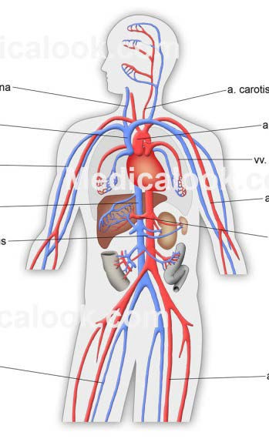

The largest level of organization is your whole body.
This level is called the organism. Organisms can carry
out all basic life processes. This means they can take in
materials, release energy from food, release wastes,
grow, respond to the environment, and reproduce.
*When you finish complete the activities on pages 3-4

PART 2: GRAPHIC ORGANIZER - Work with your team to fill out the graphic organizer below, based on the reading. I recommend you start with the middle oval of each level, then the shapes to the sides.

SMALLEST
Two examples
Cells

Cells
If the body was a city
this would be:

Six processes

LARGEST

An example
Four examples

Four types
Tissue
Tissue
Tissue
Tissue
If the body was a city
this would be:

If the body was a city
this would be:

If the body was a city
this would be:

If the body was a city
this would be:

PART 3: WHICH LEVEL? – Work with your team to answer the questions below. The answer to each question is one of the four levels of organization: cell, tissue, organ, organ system.
- What are the five levels of organization in our bodies, from smallest to largest?
(Smallest) __________→__________→__________→ __________→__________→ (Largest)

- Which level of organization is made of different types of tissue working together to perform a specific job for your body?

- Which level of organization is made of many different organs working together to perform a BIG job for your body, like digesting your food?

- Which level of organization is made of similar cells working together?
For example, many muscle cells working together.

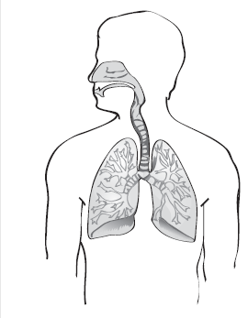
- Your heart, liver and lungs are made of many types of tissues working together. That makes your heart, liver and lungs examples of what?

- The picture to the right shows you several organs working together, including your lungs, bronchi and trachea (windpipe). This means this picture shows you a _______________ .
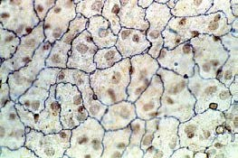
- Fill in the Blank: The picture to the right shows you many skin cells working together to form epithelial ____________.

- Which part of the human body is more complex, your heart or your circulatory system?
Explain Your Answer:

- Final Question: Why is the body so carefully organized, from small levels up to large levels? What does this careful organization help the body accomplish?
(HINT: Look back toward the beginning of the reading).

HOMEWORK
PART 4: ANALOGIES - Now, time to work independently! Remember how an analogy compares two things? For example, a cell is like a brick because they are both building blocks for big things.
Practice your understanding of the human body’s organization by completing the following analogies. Do this by matching the levels of organization of the human body – cell, tissue, organ, organ system, whole body – to the appropriate part of the analogy
EXAMPLE: City
Brick: Cell
House: Tissue
Neighborhood: Organ System City Block: Organ
Whole City: Organism
SCHOOL
_______________: Cell
_______________: Tissue
_______________: Organ
_______________: Organ System
_______________: Organism
USA
_______________: Cell
_______________: Tissue
_______________: Organ
_______________: Organ System
_______________: Organism

YOUR OWN EXAMPLE _______________________________
_______________: Cell
_______________: Tissue
_______________: Organ
_______________: Organ System
_______________: Organism
BOOK (Challenge – Add two levels that are smaller than a cell)
_______________:
_______________:
_______________: Cell
_______________: Tissue
_______________: Organ
_______________: Organ System
_______________: Organism

